**Google Data Analytics**

**Ask Questions to Make Data-Driven Decisions**

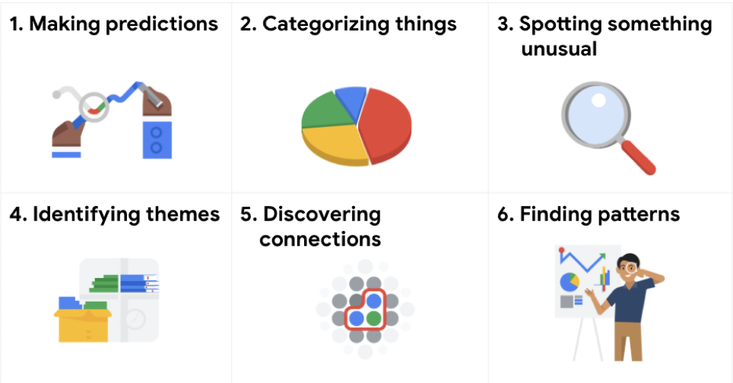

**Common Problem Types:**

**1. Making predictions:** Using data to make informed decisions about how things may be in the future.

**2. Categorising Things:** Grouping data based on common features

**3.** **Spotting something unusual:** Identifying data that is different from the norm.

**4. Identifying themes:** Recognizing broader concepts and trends from categorized data.

**5.** **Discovering connections:** Identifying similar challenges across different entities—and using data and insights to find common solutions.

**6. Finding Patterns:** Using historical data about what happened in the past to understand how likely it is to happen again.

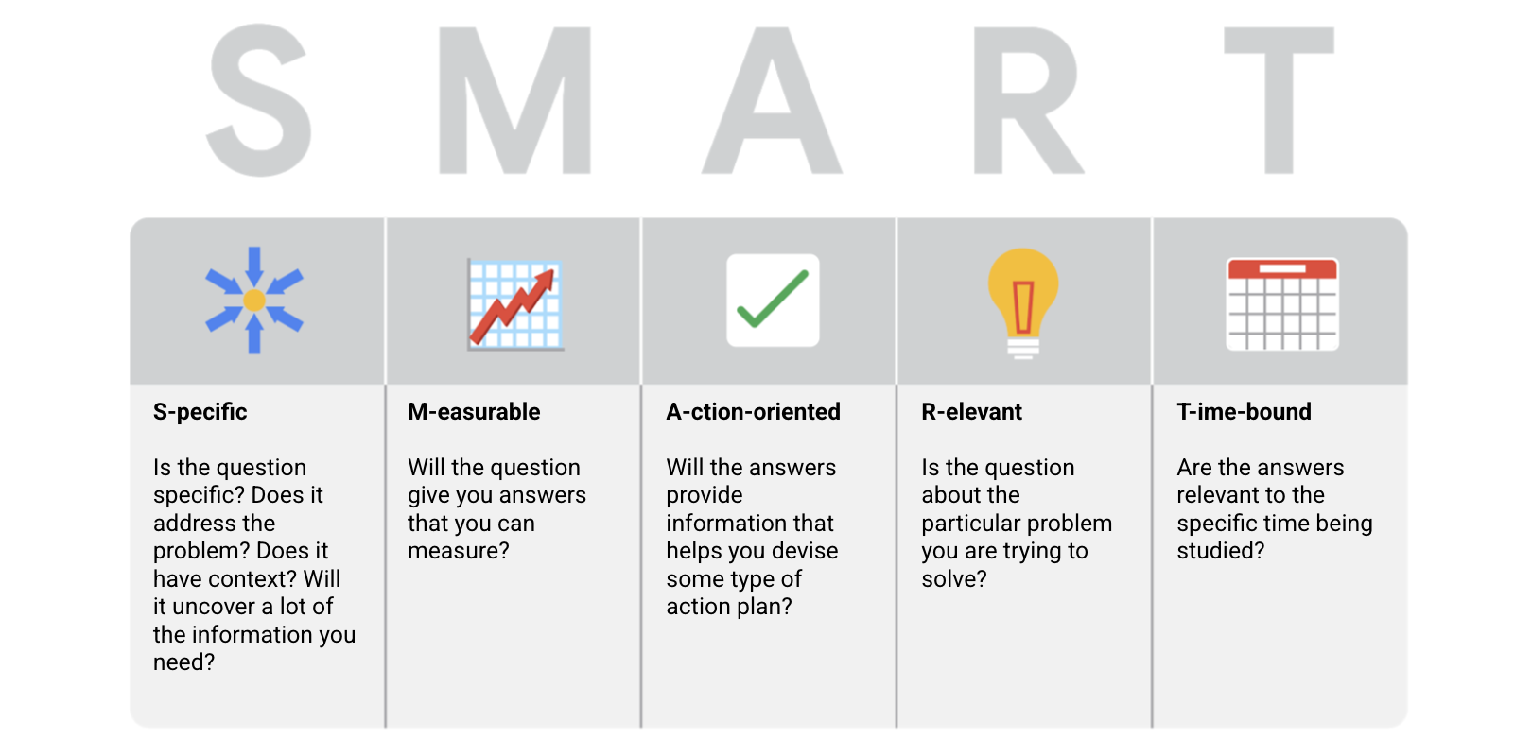

**Two ways to make decisions:**

1. **Data-driven decision making:** Making decisions based on facts
2. **Data-inspired decision making:** Explores different data sources to find out what they have in common

**Types of Data**:

1. **Quantitative data:**

Specific and objective measures of numerical facts

**Ex:** What? How many? How often?

1. **Qualitative data:**

Subjective or explanatory measures of qualities and characteristics

**Ex:** Why?

# **Qualitative and quantitative data in business:**

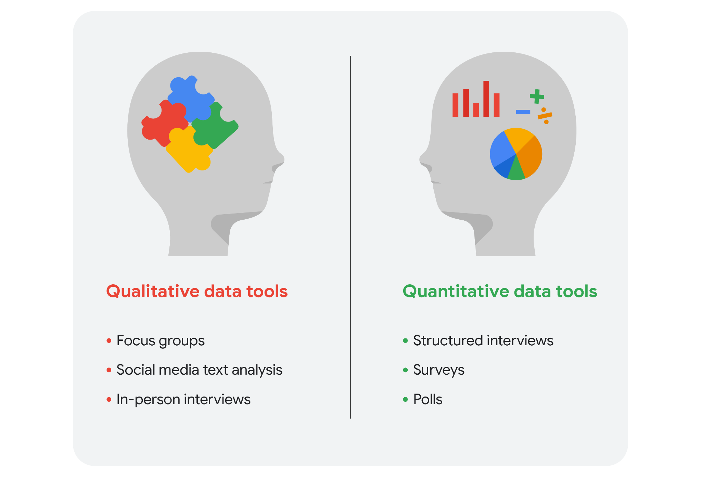

**Two data presentation tools (used for Data visualisation):**

1. **Reports:** Static collection of data given to stakeholders periodically

**Pros:**

* ﻿﻿High-level historical data
* ﻿﻿Easy to design
* ﻿﻿Pre-cleaned and sorted data

**Cons:**

* ﻿﻿Continual maintenance
* ﻿﻿Less visually appealing
* ﻿﻿Static

1. **Dashboards:** Monitors live, incoming data

**Pros:**

* ﻿﻿Dynamic, automatic, and interactive
* Low maintenance
* More stakeholder access

**Cons:**

* Can be confusing
* Labor-intensive design
* Potentially uncleaned data

**Types of dashboards:**

* **Strategic**: focuses on long term goals and strategies at the highest level of metrics

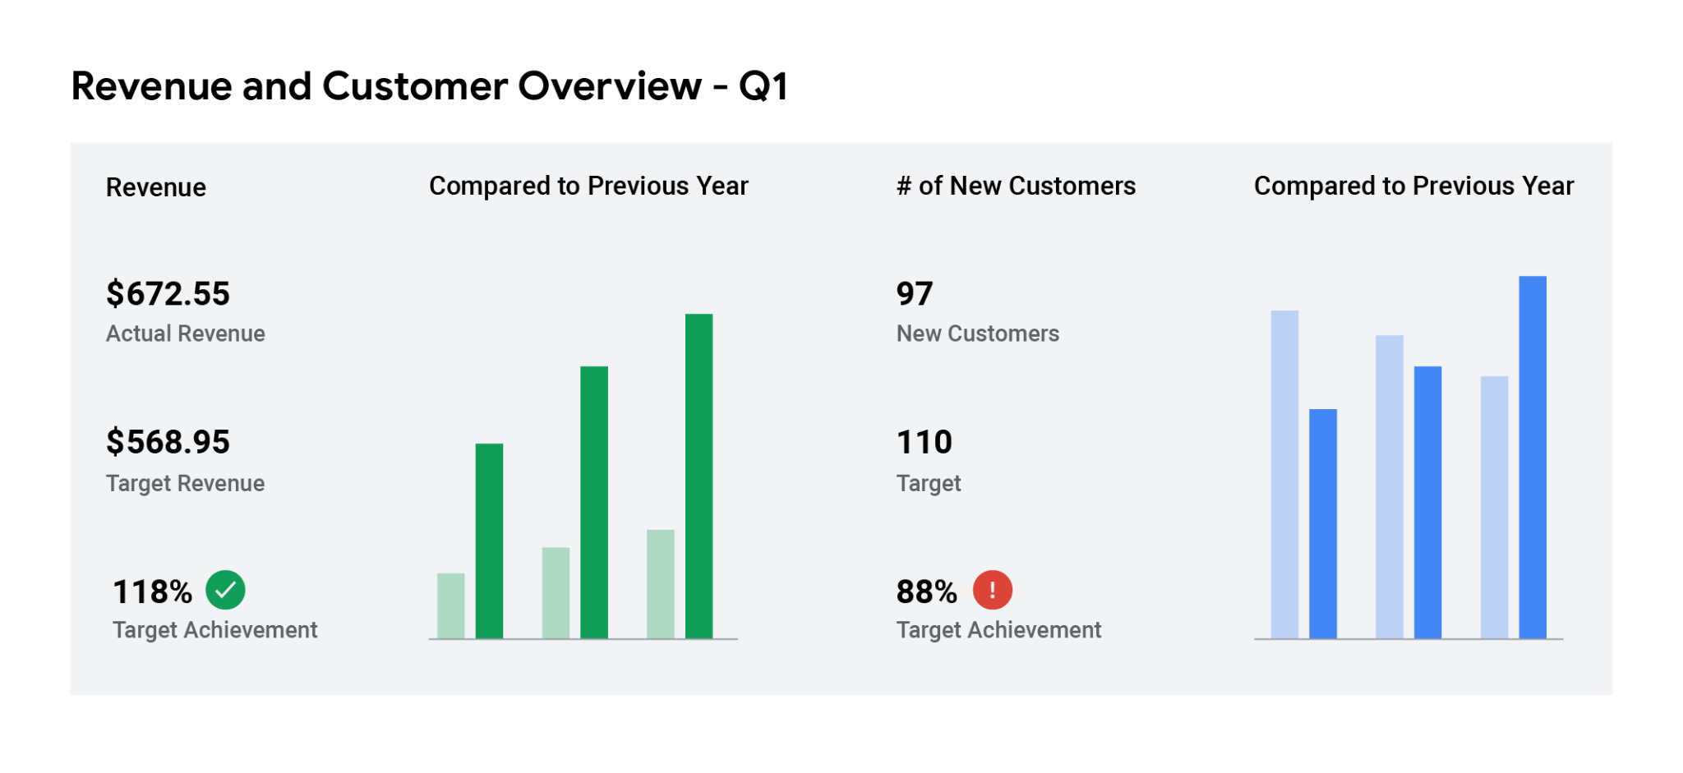

* **Operational**: short-term performance tracking and intermediate goals

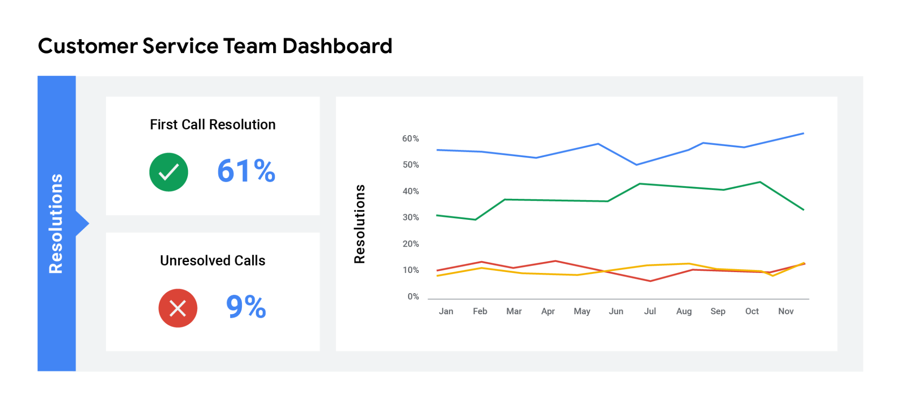

* **Analytical**: consists of the datasets and the mathematics used in these sets

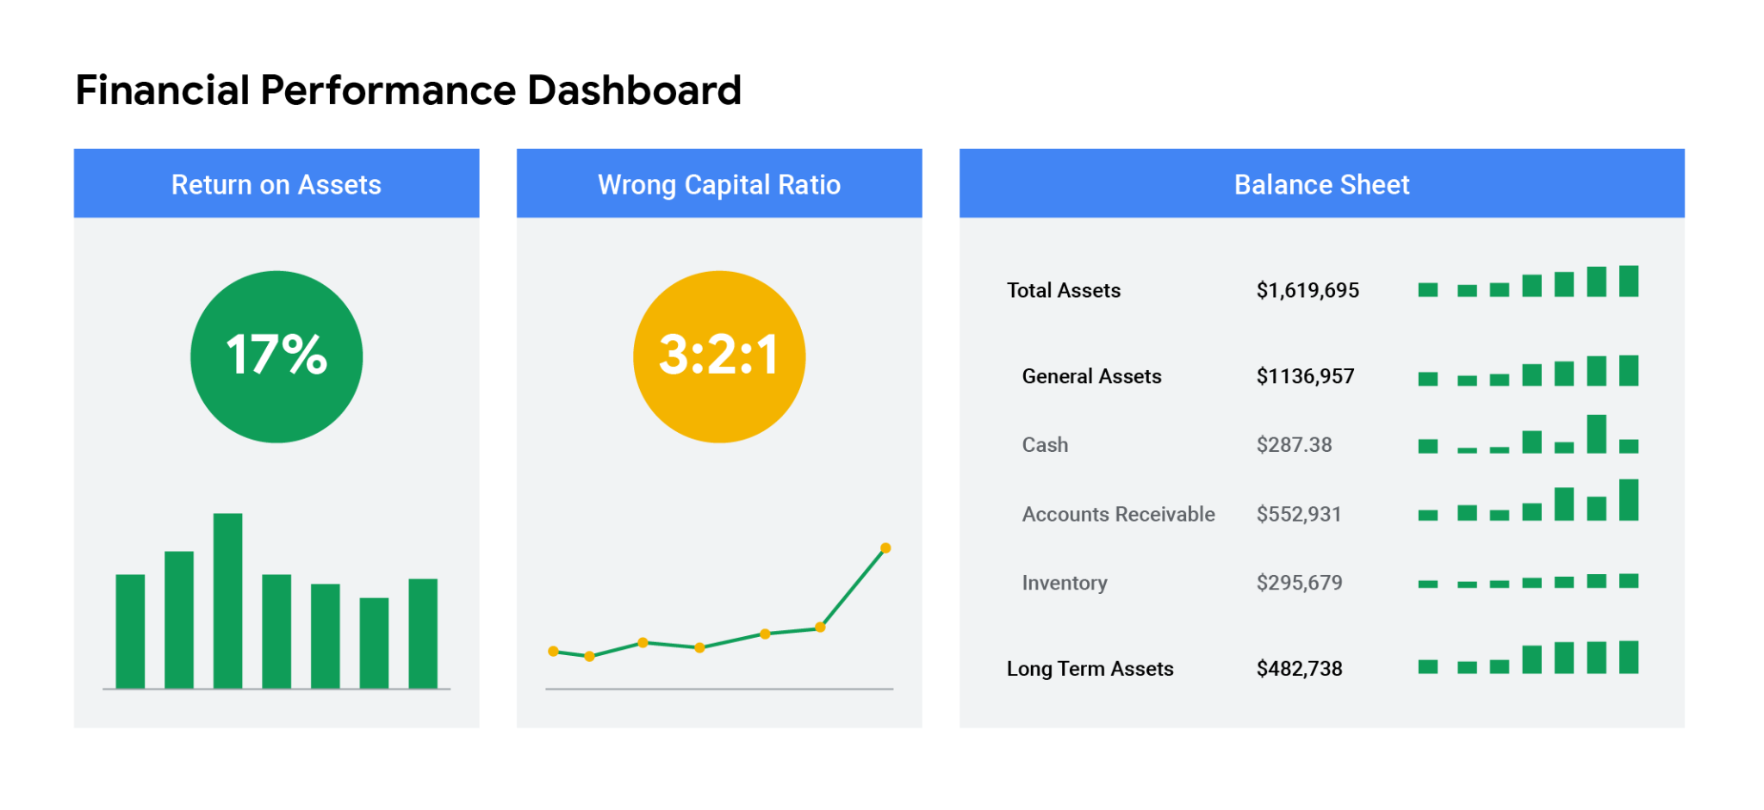

**Small and Big Data:**

| **Small data** | **Big data** |
| --- | --- |
| Describes a data set made up of specific metrics over a short, well-defined time period | Describes large, less-specific data sets that cover a long time period |
| Usually organised and analysed in spreadsheets | Usually kept in a database and queried |
| Likely to be used by small and midsize businesses | Likely to be used by large organisations |
| Simple to collect, store, manage, sort, and visually represent | Takes a lot of effort to collect, store, manage, sort, and visually represent |
| Usually already a manageable size for analysis | Usually needs to be broken into smaller pieces in order to be organised and analysed effectively for decision-making |

**When thinking about the benefits and challenges of big data, it helps to think about the three Vs:**

| **Volume** | **Variety** | **Velocity** | **Veracity** |
| --- | --- | --- | --- |
| The amount of data | The different kinds of data | How fast the data can be processed | The quality and reliability of the data |

**Data Life Cycle:**

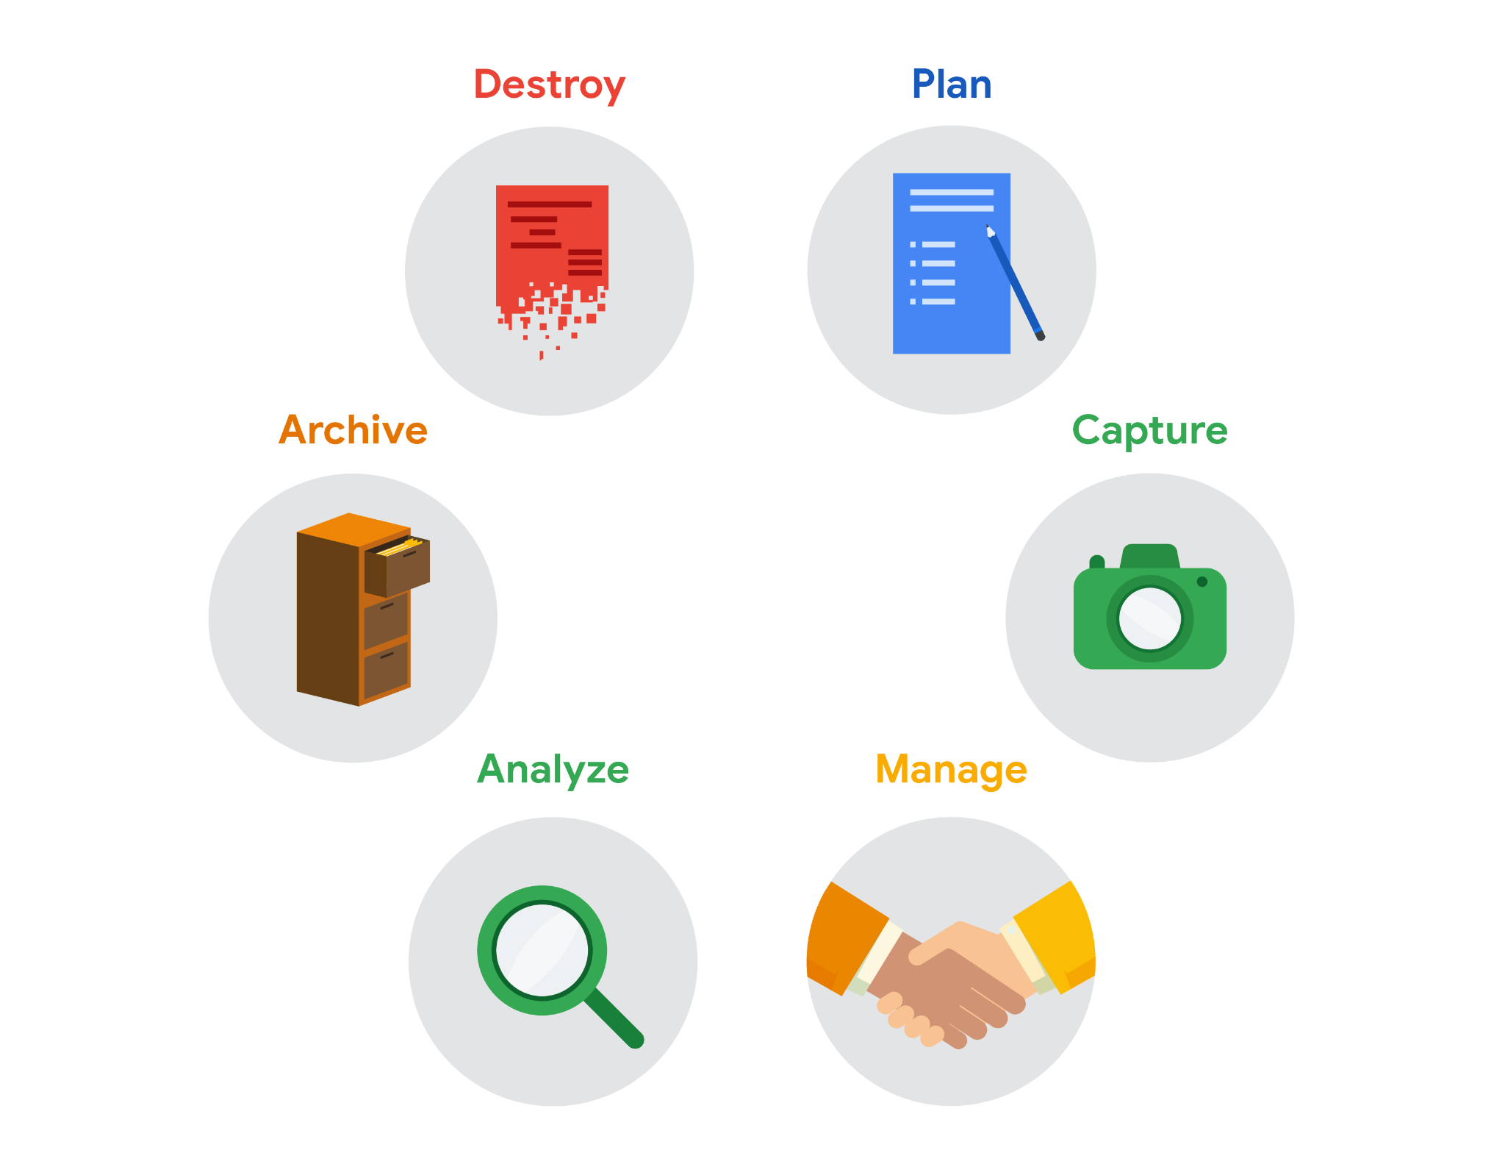

**Scope-of-Work vs Statement-of-Work:**

At this point, try not to confuse statement of work with scope of work, which are both abbreviated as SOW. Although they both are used to define deliverables and a timeline, they aren't the same and shouldn't be used interchangeably.

A statement of work is a document that clearly identifies the products and services a vendor or contractor will provide to an organisation. It includes objectives, guidelines, deliverables, schedule, and costs.

A scope of work is project-based and sets the expectations and boundaries of a project. A scope of work may be included in a statement of work to help define project outcomes

**Scope-of-Work:**

SOW might not be same for all organisations however they all have a few foundational pieces of content in common:

**Deliverables**: What work is being done, and what things are being created as a result of this project? When the project is complete, what are you expected to deliver to the stakeholders? Be specific here. Will you collect data for this project? How much, or for how long?

**Milestones**: This is closely related to your timeline. What are the major milestones for progress in your project? How do you know when a given part of the project is considered complete?

**Timeline**: Your timeline will be closely tied to the milestones you create for your project. The timeline is a way of mapping expectations for how long each step of the process should take. The timeline should be specific enough to help all involved decide if a project is on schedule. When will the deliverables be completed? How long do you expect the project will take to complete? If all goes as planned, how long do you expect each component of the project will take? When can we expect to reach each milestone?

**Reports**: Good SOWs also set boundaries for how and when you’ll give status updates to stakeholders. How will you communicate progress with stakeholders and sponsors, and how often? Will progress be reported weekly? Monthly? When milestones are completed? What information will status reports contain?

**Contextualizing Data:**

To do this, you need to identify:

* Who: The person or organisation that created, collected, and/or funded the data collection
* What: The things in the world that data could have an impact on
* Where: The origin of the data
* When: The time when the data was created or collected
* Why: The motivation behind the creation or collection
* How: The method used to create or collect it

**Stakeholders’ Expectations:**

As a data analyst, it is your responsibility to understand and manage your stakeholders’ expectations while keeping the project goals front and centre

This can be a pretty broad group, and your project stakeholders may change from project to project. But there are **three common stakeholder groups** that you might find yourself working with: **the executive** **team**, **the customer-facing team**, and **the data science team**.

**Executive Team:**

provides strategic and operational leadership to the company. They set goals, develop strategy, and make sure that strategy is executed effectively. The executive team might include vice presidents, the chief marketing officer, and senior-level professionals who help plan and direct the company’s work

**Customer-facing team:**

The customer-facing team includes anyone in an organisation who has some level of interaction with customers and potential customers

**Data Science Team:**

There's a good chance you'll find yourself working with other data analysts, data scientists, and data engineers. A big part of your job will be collaborating with other data team members to find new angles of the data to explore.

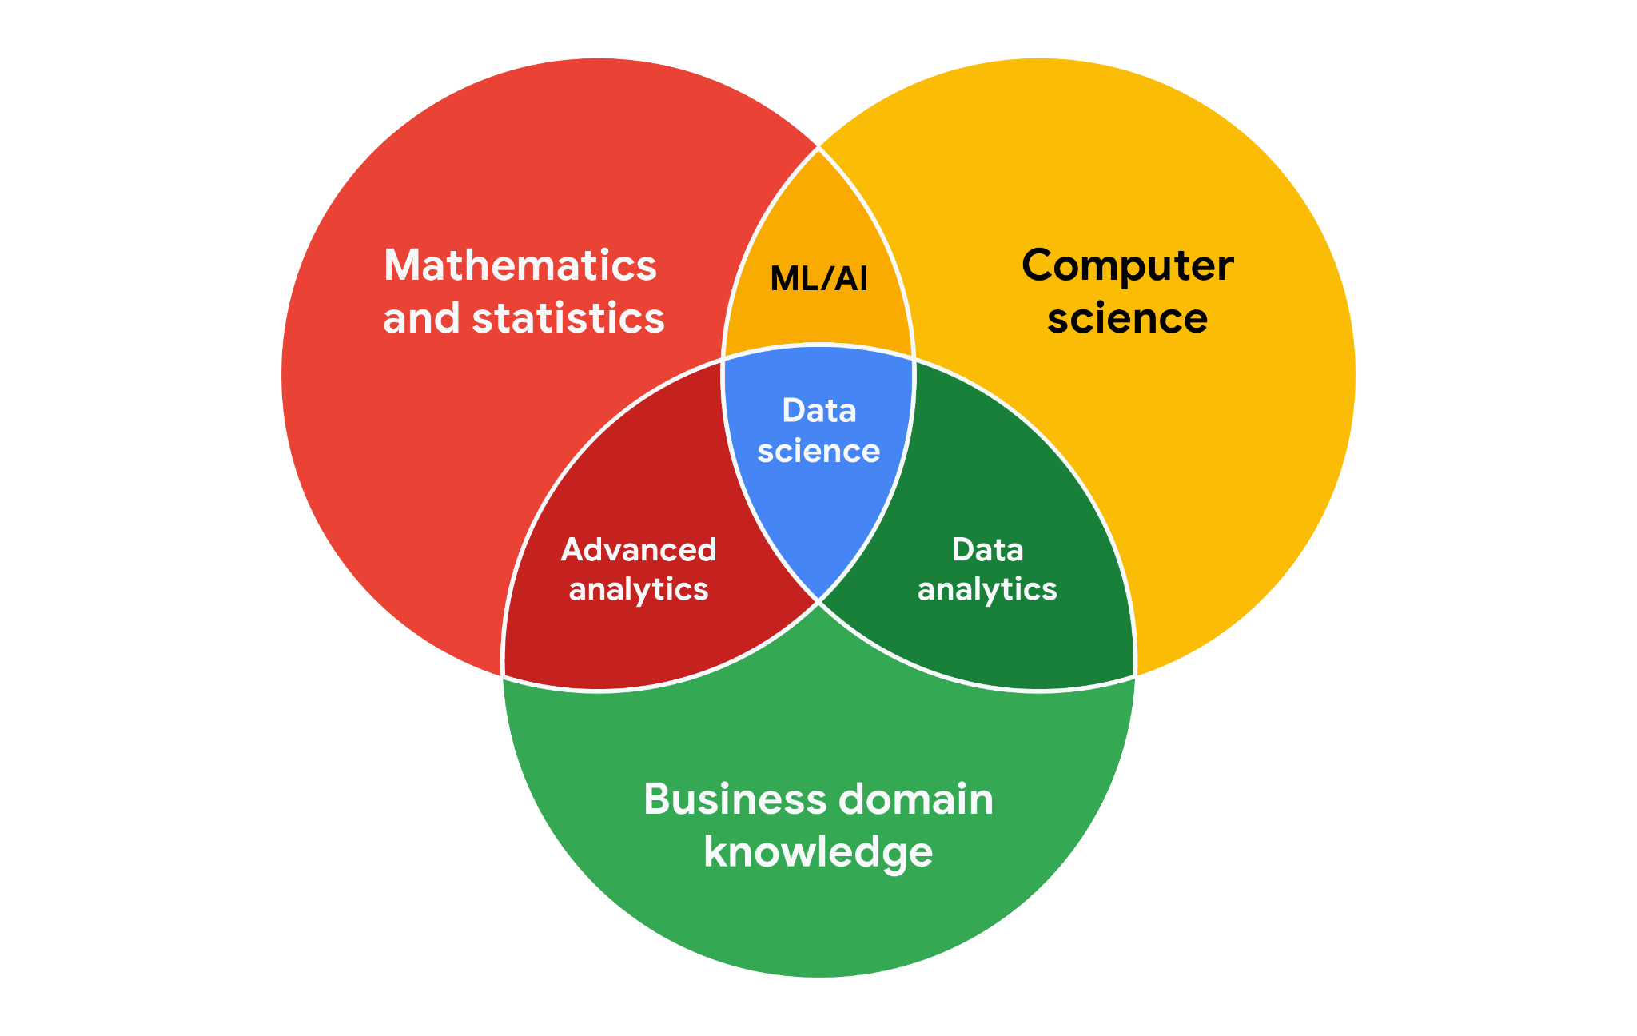

**Working effectively with stakeholders:**

* Discuss goals
* Feel empowered to say “no.”
* Plan for the unexpected
* Know your project
* Start with words and visuals
* Communicate often

**Focus on What Matters:**

To focus on objective and not be swayed by other Stakeholders’ need, we can ask the following questions:

1. ﻿﻿﻿Who are the primary and secondary stakeholders ?
2. ﻿﻿﻿Who is managing the data?
3. ﻿﻿﻿Where can you go for help?

**Communication:**

As a data analyst communication with Stakeholders or team members is key.

Before you communicate, think about

1. ﻿﻿﻿Who your audience is
2. ﻿﻿﻿What they already know
3. ﻿﻿﻿What they need to know
4. ﻿﻿﻿How you can communicate that effectively to them

While starting as a beginner you might feel a little out-of-sync with the rest of the team and how they communicate, but you will figure things out eventually if **learn as you go and ask questions.**

Some work environments may have etiquettes (like a firm handshake, a bow, or eye contact) which you must follow for an effective and professional communication(in-person or online communication).

**Listening**, **speaking**, **presenting**, and **writing** skills will help you succeed in your projects and in your career.

**Case Study:**

Avinash Kaushik, a Digital Marketing Evangelist for Google, has lots of great tips for data analysts in his [blog: Occam's Razor](http://www.kaushik.net/). Below are some of the best practices he recommends for good data storytelling:

* **Compare the same types of data**: Data can get mixed up when you chart it for visualization. Be sure to compare the same types of data and double check that any segments in your chart definitely display different metrics.
* **Visualise with care**: A 0.01% drop in a score can look huge if you zoom in close enough. To make sure your audience sees the full story clearly, it is a good idea to set your Y-axis to 0.
* **Leave out needless graphs:** If a table can show your story at a glance, stick with the table instead of a pie chart or a graph. Your busy audience will appreciate the clarity.
* **Test for statistical significance:** Sometimes two datasets will look different, but you will need a way to test whether the difference is real and important. So remember to run statistical tests to see how much confidence you can place in that difference.
* **Pay attention to sample size**: Gather lots of data. If a sample size is small, a few unusual responses can skew the results. If you find that you have too little data, be careful about using it to form judgments. Look for opportunities to collect more data, then chart those trends over longer period

**Meetings:**

Meetings are a huge part of how you communicate with your team and stakeholders

**Do**

* ﻿﻿Come prepared
* ﻿﻿Be on time
* ﻿﻿Pay attention
* ﻿﻿Ask questions
* ﻿﻿Bring what you need
* ﻿﻿Read the meeting agenda
* ﻿﻿Prepare notes and presentations (if you lead)
* ﻿﻿Be ready to answer questions (if you lead)
* Prepare and send the agenda to the team members beforehand (if you lead)
* Try to engage with all audience and let them know you are open to questions after meeting too

**Don't**

* ﻿﻿Show up unprepared
* ﻿﻿Arrive late
* ﻿﻿Be distracted
* ﻿﻿Dominate the conversation
* ﻿﻿Talk over others
* ﻿﻿Distract people with unfocused discussion

## **Before the meeting**

If you are organizing the meeting, you will probably talk about the data. Before the meeting:

* **Identify your objective**. Establish the purpose, goals, and desired outcomes of the meeting, including any questions or requests that need to be addressed.
* **Acknowledge participants** and keep them involved with different points of view and experiences with the data, the project, or the business.
* **Organise the data** to be presented. You might need to turn raw data into accessible formats or create data visualisations.
* **Prepare and distribute an agenda**. We will go over this next

## **Crafting a compelling agenda**

A solid meeting agenda sets your meeting up for success. Here are the basic parts your agenda should include:

* Meeting start and end time
* Meeting location (including information to participate remotely, if that option is available)
* Objectives
* Background material or data the participants should review beforehand

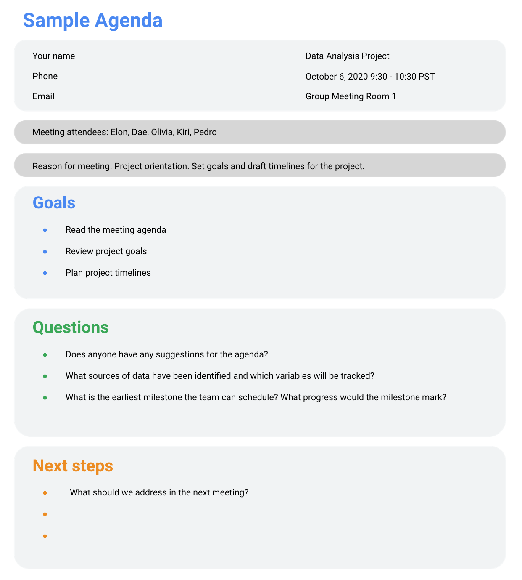

## 

## **During the meeting**

As the leader of the meeting, it's your job to guide the data discussion. With everyone well informed of the meeting plan and goals, you can follow these steps to avoid any distractions:

* Make introductions (if necessary) and review key messages
* Present the data
* Discuss observations, interpretations, and implications of the data
* Take notes during the meeting
* Determine and summarise next steps for the group

## **After the meeting**

To keep the project and everyone aligned, prepare and distribute a brief recap of the meeting with next steps that were agreed upon in the meeting. You can even take it a step further by asking for feedback from the team.

* Distribute any notes or data
* Confirm next steps and timeline for additional actions
* Ask for feedback (this is an effective way to figure out if you missed anything in your recap)

**Conflict Resolution:**

Even after careful planning conflicts may occur, and you need to quickly resolve them and move forward, some of the ways are:

* Reframe the problem
* Start a conversation
* Understand the context